The Visual Art Department at Ranney School Presents:
Experiential Learning- A trip to see and reflect on works of art – In New York City
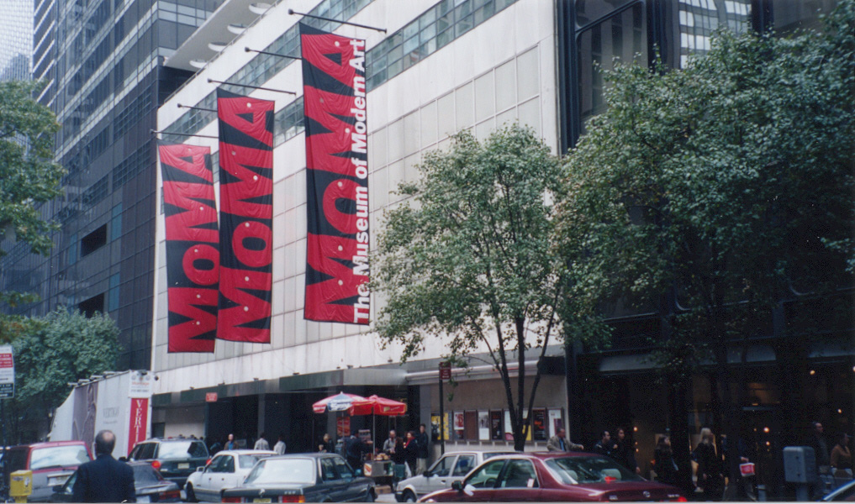

WHERE : Museum of Modern Art & The Museum of Art and Design
WHEN: Thursday December 11, 2014, 8:30- 5:00
WHO: Honors Sculpture, AP Studio Art, AP Art History

Please return permission form to Ms. Greenberg by Monday December 8th.

___________________________________ has my permission to participate in this trip to the Museum of Modern Art and the Museum of Art and Design. As this experiential learning trip is an essential part of the course curricula, each student is expected to attend. Department faculty will be chaperones, and students have specific assignments to be completed at the museums.

Dress Requirements: Students may dress up for this field trip or wear dress code. They may not wear t-shirts, jeans or flip flops.
Lunch: is in one of MoMA’s restaurants. Students may choose which restaurants and students with specific dietary needs may bring lunch. Estimated cost of lunch is $15.00. You may also want to bring money for the museum gift shop.
*Under no circumstances can students leave the museum or be left in New York to meet family or friends.

8:40 Depart from Ranney School
10:15-11:45 Museum of Art and Design (MAD)
12:30-1:00 Lunch at MoMA
1:15-3:15 MoMA self-guided research assignment
5:00 Return to Ranney

Please note that we will return to Ranney School after the busses have left and your child will need transportation home.

_____________________________PRINT NAME/ Guardian Signature ___________________________________

