Making Art: Process, Materials, Meaning
In this project, you will continue to develop the idea of identity and build on the 5 objects still life. From a traditional still life you will manipulate this drawing (or copy of it) using a selection of the techniques and materials below. Use this as a starting point and cut, rearrange, take away, add, draw more abstractly, experiment with new materials and techniques. Maintain the same size as the first work.
It is important that you take risks, experiment, and look for ways to tell us more about yourself.
Choose 3 mediums | Choose 2 textures | Choose at least 2 ways to puncture
Chalk pastel  Oil pastel  Acrylic paint  Ink  Watercolor  Color pencil  printmaking | Gesso  Matt or gloss medium  Grattage (rubbings)  Frottage (scraping layers of paint)  Modge Podge  Weave paper | Cut/ tear  Sew  Grommet  Rearrange
Sample works by students who have cut up and manipulated their drawings.
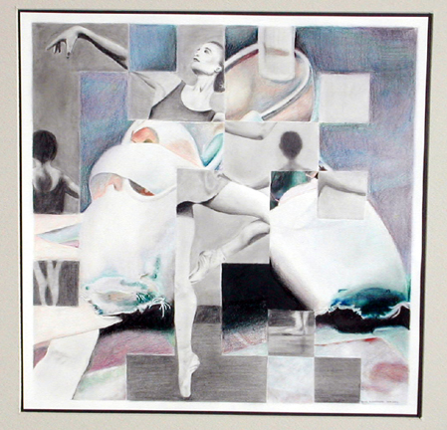
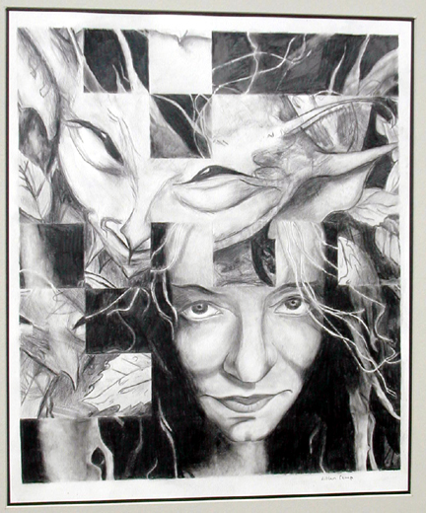

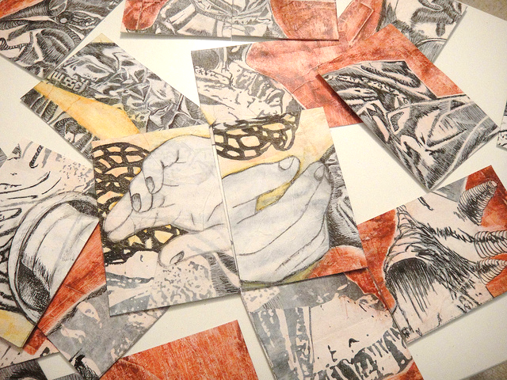

Rubric
90-100 | Student used the materials and techniques from all three categories and took risks to experiment.  Student used the techniques above to further describe or give insight into her identity.  Student used the elements and principles of design to achieve a dynamic work.  Student presents a novel or unique solution and develops her own voice
89-80 | Student did not meet all the requirements of the categories above but did use some  Student included new materials and techniques but they did not further the exploration of identity  Student used the elements but did not apply the principles of design  Student introduced new imagery but did not advance the cause of expanding our knowledge about her identity or personal voice
79-70 | Student used only 1 medium or technique from each category  Student did not include new imagery, color or abstract forms that advanced our understanding of identity  Student did not use new methods or the principles of design to create a dynamic composition  Student used materials, techniques and imagery in a routine way and brought nothing of their personal voice to the work.
69-64 | Student used none of the mediums or techniques from the categories above  Students did not use any materials, techniques or imagery to advance the complexity of composition or identity.  Student does not use the principles of design to achieve a successful composition

