Art Principles
The Annotated Mona Lisa
Test Pages 1-29, Prehistoric through Medieval art

Unless otherwise marked, all questions are worth 2.5 pts.

- Art historians and archeologists speculate that prehistoric art was made for what purpose?

- What do we speculate Stonehenge was built for?

- Explain the structure and purpose of the Ziggurat?

- What word best describes the focus or Egyptian culture? And what techniques and buildings did they develop as a direct result of this cultural vale?

- Describe the rigid formula for portraying the human figure.

- What culture is known for the quote “Man is the measure of all things”?

- What form was the central motif of Greek art?

- Explain the concept of Contrapposto.

- What was the purpose of the buildings on the Acropolis?

- What message does the Greek architectural style communicate and give an example of an 18th century building that is influenced by Greek architecture?

- (worth 9 pts)
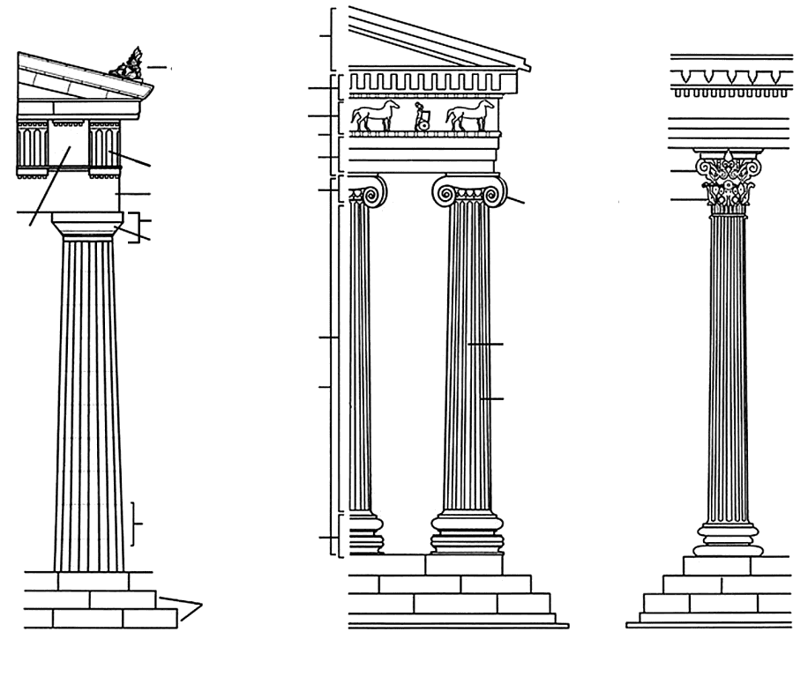 | Identify the following:  Place the letter on the diagram.  - Pediment  - Shaft  - Capital  - Metope  - Triglyph  - Doric Order  - Ionic Order  - Corinthian Order  - Base

- What terms would you use to describe the Roman civilization?

- Name 4 inventions in architecture and engineering credited to the Romans. (worth 4 pts)

a.

b.

c.

d.

- How did Roman art serve the needs of the rulers?

- What influence does the colosseum have on architecture today?

- While it was a feat of engineering what is the darker side of the colosseum?

- What does the term Pre-Columbian refer to?

- What are the characteristics of African art?

- Name an artist or group of artists and how they were influenced by African Art.

- Why is the Middle Ages sometimes called the Age of Faith or the Reign of Religion?

- Name the three major cultural shifts that occurred and far reaching effects on Western civilization. (worth 3 pts.)
a.

b.

c.

- Why do works of art change in style from the naturalistic art of the Roman Empire to the more symbolic representation of the world?

- Name 5 differences between Romanesque and Gothic architecture (worth 10 pts)
Romanesque | Gothic
1. | 1.
2. | 2.
3. | 3.
4. | 4.
5. | 5.

- Why were architects in the Gothic style able to make the churches taller?

- Name 7 architectural elements that characterize Gothic architecture. (worth 7 pts)

a.

b.

c.

d.

e.

f.

g.

- What role did stained glass play in the church? What impact did poor literacy rates play in the development of stained glass?

Questions 27-30

Work of Art | Culture or Style
